IMAGE TRANSMISSION BASED OFDM CHANNEL ESTIMATION OVER DWT BASED CARRIER MODULATION TECHNIQUE

ABSTRACT:
In modern wireless communication systems, the reliable transmission of multimedia data such as images is a major challenge due to noise, interference, and channel fading. Orthogonal Frequency Division Multiplexing (OFDM) is widely used to overcome these issues because of its high data rate capability and robustness against multipath fading. However, conventional OFDM systems based on Fast Fourier Transform (FFT) suffer from high Peak-to-Average Power Ratio (PAPR) and spectral inefficiency.This project presents a basic-level study of image transmission using OFDM with Discrete Wavelet Transform (DWT)–based carrier modulation and channel estimation. DWT-based OFDM replaces the conventional FFT with wavelet transforms, resulting in better spectral efficiency and reduced PAPR. Channel estimation techniques are applied to estimate channel characteristics and improve image reconstruction quality at the receiver. The proposed system demonstrates improved performance in terms of image quality, noise resistance, and efficient bandwidth utilization.

INTRODUCTION
With the rapid growth of wireless communication technologies, the demand for high-quality multimedia transmission has increased significantly. Image transmission plays a vital role in applications such as medical imaging, satellite communication, surveillance systems, and wireless multimedia services. However, transmitting images over wireless channels is challenging due to noise, interference, and multipath fading, which can distort the received image.Orthogonal Frequency Division Multiplexing (OFDM) is a popular modulation technique used in modern communication systems such as LTE, Wi-Fi, and digital broadcasting. OFDM divides the available bandwidth into multiple orthogonal subcarriers, allowing parallel data transmission. This makes OFDM highly resistant to inter-symbol interference caused by multipath propagation. Despite its advantages, traditional FFT-based OFDM systems suffer from drawbacks such as high Peak-to-Average Power Ratio (PAPR) and sensitivity to synchronization errors.To overcome these limitations, Discrete Wavelet Transform (DWT)–based OFDM has been introduced. In DWT-based OFDM, wavelet transforms are used instead of FFT to generate subcarriers. This approach provides better time-frequency localization, improved spectral efficiency, and reduced PAPR. As a result, DWT-based OFDM is more suitable for efficient image transmission over wireless channels.Another critical aspect of wireless communication is channel estimation. Wireless channels are time-varying and introduce distortion to the transmitted signal. Channel estimation techniques use known pilot or reference signals to estimate channel conditions. Accurate channel estimation helps the receiver to compensate for channel effects and recover the transmitted image with higher quality.This project focuses on a simple and conceptual implementation of image transmission using OFDM with DWT-based carrier modulation and channel estimation. The system is designed at a basic level using simulation tools, making it suitable for diploma and undergraduate students. The main goal is to analyze how DWT-based OFDM and channel estimation improve image quality and system performance.

OBJECTIVES
- To study image transmission using OFDM.
- To understand DWT-based carrier modulation technique.
- To analyze basic channel estimation methods.
- To improve received image quality.
- To compare performance with conventional OFDM systems.

PROBLEM STATEMENT
Conventional FFT-based OFDM systems used for image transmission suffer from high PAPR and reduced performance under noisy wireless channels. There is a need for an improved modulation technique combined with channel estimation to enhance image transmission quality over OFDM systems.

EXISTING SYSTEM
- Image transmission using FFT-based OFDM.
- Limited resistance to noise and fading.
- Higher PAPR.
- Basic channel estimation techniques.

DISADVANTAGES OF EXISTING SYSTEM
- Degraded image quality under noise.
- High PAPR causing power inefficiency.
- Spectral leakage.
- Reduced performance in multipath channels.

PROPOSED SYSTEM
The proposed system uses DWT-based OFDM for image transmission. The input image is converted into a binary data stream and modulated using DWT-based OFDM. Pilot symbols are inserted for channel estimation. At the receiver, channel estimation and equalization are performed to reduce channel distortion. The received data is demodulated and reconstructed into the original image. This approach improves spectral efficiency and image quality.

ADVANTAGES OF PROPOSED SYSTEM
- Improved image quality.
- Reduced PAPR.
- Better spectral efficiency.
- Improved performance in noisy channels.
- Simple and efficient implementation.

BLOCK DIAGRAM
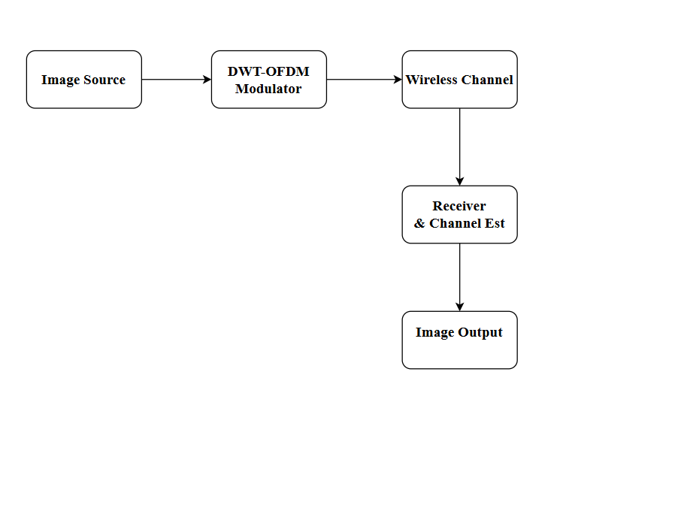
SOFTWARE
- MATLAB
- Image Processing Toolbox
- Communication Toolbox

REFERENCE:
[1] M.K Lakshmanan and H.Nikoobar, “A review of wavelets for digital wireless communication”, Journal on Wireless Personal Communication, Vol.37, no.3-4, pp.387- 420, Springer, May 2006.
[2] C.Christopoulos, A. Skodras, and T.Ebrahimi,”The JPEG2000 still image coding system: An overview”, IEEE Transaction Consumer Electron, Vol.46, no.4, pp.1103-127, Nov 2000.
[3] Y.Li and G.L.Stueber, “Orthogonal frequency division multiplexing for wireless communication”, Springer, 2005.
[4] S.Weinstein and P.Ebert, “Data transmission by Frequency Division Multiplexing using the Discrete Fourier Transform”, IEEE Transaction on Communication Technology, Vol.19, no.5, pp.628-634, Oct1971.
[5] Radhika v. Totala, K.S.Bapat, “Comparative Analysis of Watermarking in Digital Images Using DCT& DWT”, International Journal of Scientific and Research Publications, Vol.3, ISSN 2250-3153, Feb 2013.
[6] M. Mozammel Hoque Chowdhury and Amina Khatun, “Image Compression Using Discrete Wavelet Transform”, IJCSI International Journal of Computer Science Issues, Vol.9, no.1, Jul 2012.
[7] Y.Li, “Pilot-symbol-aided channel estimation for OFDM in Wireless systems”, IEEE Trans.Veh.Techn, Vol.49, no.4, pp.1207-215, Jun 2000.
[8] Ashwani Sharma, Swades De, and Hari Mohan Gupta,”Energy Efficient transmission of DWT image over OFDM fading channel, Communications Systems and Networks (COMSNETS, 2011 Third International Conference on, Vol.; no., pp.1, 7,4-8, Jan 2011.
[9] J.McEliece and W.E.Stark, “Channels with block interference”, IEEE Transaction information .Theory, Vol.30, no.1, pp.44-53, Jan 1984.
[10] R.Knopp and P.A.Humblet, “On coding for block fading channels”, IEEE Trans.info.Theory, Vol.46, no.1, pp.189-205, Jan 2000.

